**3. Reactjs-HOL**

Question:- Create a react app for Student Management Portal named scorecalculatorapp and create a function component named “CalculateScore” which will accept Name, School, Total and goal in order to calculate the average score of a student and display the same.

**Step 1.** Create the react app named scorecalculatorapp using command

**“npx create-react-app scorecalculatorapp”**



**Step 2.** Now change the folder using command **“cd scorecalculatorapp”**



**Step 3**. Create a new folder under Src folder with the name “Components”. Add a new file named “CalculateScore.js”, and type the following code.

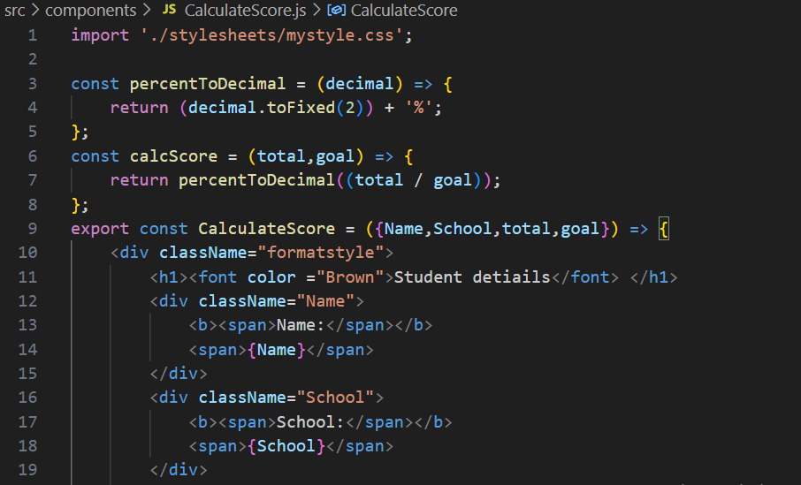

**Step 4**. Add a mystyle.css file

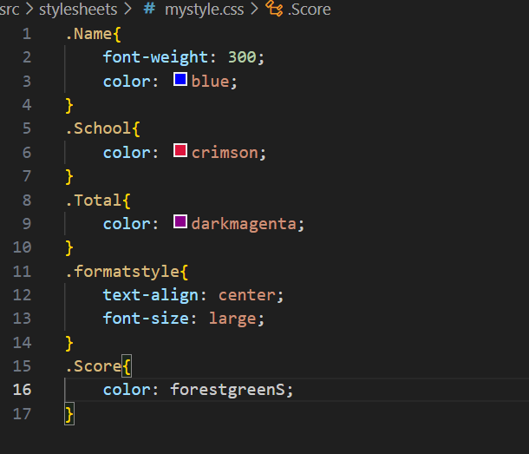

**Step 5.** Invoke CalculateScore functional component in app.js

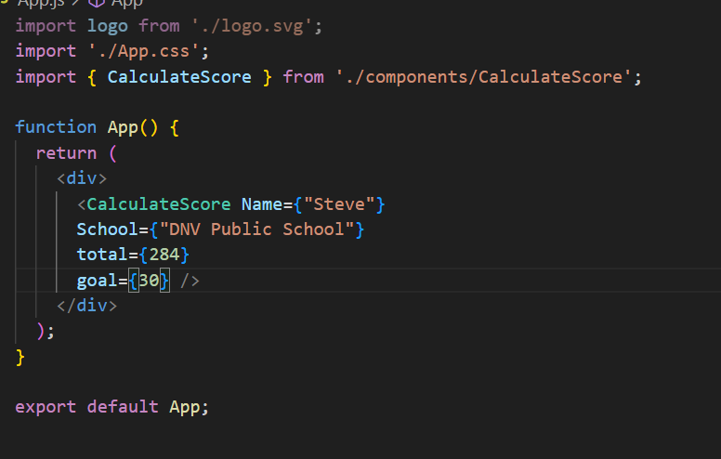

**Step 6.** Start the server by **“npm start”** command.

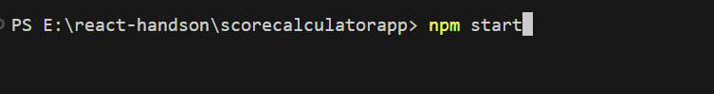

**Output:-** Output should look like this:

